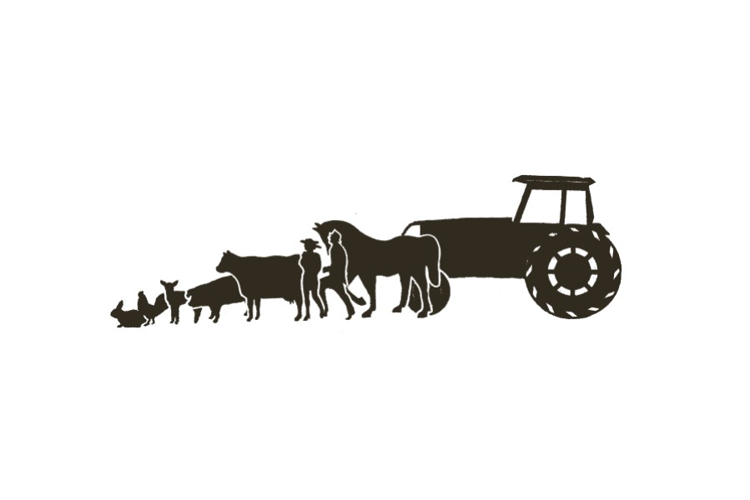
Friday, September 29, 2023, 9am-4pm
Free Gate Admission ---Preschool to Age 18

Calvert County Fairgrounds, Rt. 231, Barstow, MD 20610
www.calvertcountyfair.com
9 am Fair & Carnival Open – Reduced ride prices for Ages up to 18 until 4 pm
All Rides take 1 ticket @$1.00 each or 25 for $20.00
9 am – 3:45 pm Gift Card Bike Drawing Registration (Drawing at 3:55 pm) Main Street
Do Not have to be present to win, but must be present to register
Gift Cards for Bikes donated by Calvert County 4-H All Stars
9:30 am – 3:30 pm Rock Painting Exhibit Blvd.
9:30 am – 10:00 am Black Belt Academy – Master Kyle Webber - Show #1 Pavilion Stage
10:00 – 12 Noon Games & Contests Beside Track Beside Track Area
Sequence of Events: 3-Legged Race, Bean Bag Toss,
Frisbee Toss, Wheelbarrow Race and More
10 am – 1 pm Youth Day Puzzle and Word Find in Progress – Chick-Fil-A Main Street
10 am – 2 pm Baseball Throw/Fast Pitch Front Fence
Sponsored by Calvert County Sheriff’s Department
10:00 – 10:45 am Beach Buccaneers Cheer Team Pavilion Stage
10:45 Pie Eating Contest Grades K – 5th and enrolled in school – Pre-registration Exhibit Blvd.
10:45 – 11:30 am ‘Raptors of Southern Maryland Show” by Nanjemoy Creek Pavilion Stage
Environmental Education Center
11:30 am – 1 pm Hula Hoop, Hog Calling & “Minute to Win It” Pavilion Stage
1 pm K-9 Demonstration Sponsored by Sheriff’s Dept. Beside Track
1:05 – 1:50 pm Calvert School of Dance Pavilion Stage
2 pm Punt, Pass, & Kick Contest for Ages 8 – 13 Beside Track Area
Register at 1:30 pm at Barn – Sponsored by Optimist Club
of Calvert-Prince Frederick Gray Barn
2-2:30 pm Black Belt Academy – Master Kyle Webber – Show #2 Pavilion Stage
2:30 pm Pie Eating Contest for Lord Calvert & Miss Tranquility and Contestants Exhibit Blvd.
3:00 – 3:45 pm BADD Company Dance Studio Pavilion Stage
3:45 pm Closing of Gift Card Bike Registration Main Street
3:55 pm Gift Card Bike Drawing for Girl’s & Boy’s Bike Pavilion Stage
Need not be present to win, but must be present to register by 3:45 pm
4:00 pm YOUTH DAY 2023 OFFICIALLY CLOSES – REGULAR GATE & RIDE PRICES BEGIN
YOUTH DAY DISPLAYS & EVENTS: 9 am – 4 pm *Calvert Cadet Squadron, Civil Air Patrol, U.S. Air Force Auxiliary *Calvert County Library *Calvert County Master Gardeners *Calvert Co. Parks & Rec. & Calvert Nature Society *Calvert Co. Public Schools * Calvert Environmental Commission *Calvert Spinners and Weavers *Face Painting by CHS Art Honor Society *Farmer for the Day *4-H Passport to Ag *Girl Scouts SU 11-9, *Head Start *Health Dept. Healthy Activities *Healthy Families *Jefferson Patterson Park and Museum *Judy Center *Maryland Coalition of Families (MCF) *”Pinch”, the Blue Crab *Surfing Museum, Bruce “Snake” Gabrielson
OTHER FAIR ENTERTAINMENT SCHEDULED AT VARIOUS TIMES FROM 9 am TO 4 pm
*Joseph Stebbing, Jr. Chainsaw Sculpture *Maryland Agriculture Showcase Trailer *Urias Daredevil, Aerial & Acrobatic Thrill Show *Big Bee *Nature Play Space put on by Pure Play Every Day
SPECIAL CHALLENGE FOR 2023 YOUTH DAY STUDENT ATTENDEES – (Preschool – Age 18)“Let’s Provide a Mountain of Food to Help Feed the Hungry!” Please Bring a Can of Food and Leave it at the Entry Gate from 9 am to 4 pm. Foods Collected will be distributed to Area Food Banks. Together We Can Make a Difference!!

